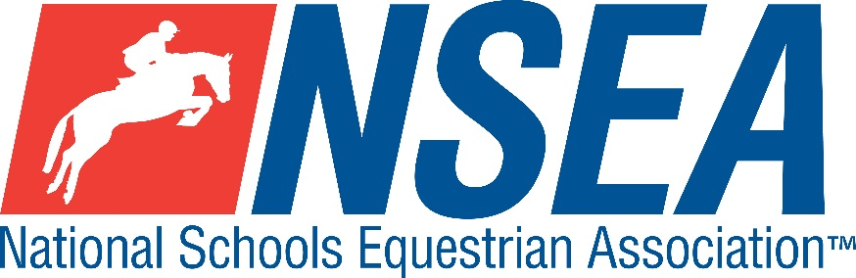
National Schools
NSEA Combined Training Qualifiers

Penskyber Equestrian Centre
Letterston, Haverfordwest, SA62 5TJ
Sunday 6th September 2026

1st & 2nd placed team & 1-4th placed individuals will qualify for the
NSEA National Schools Championships 2026
October 2026
Entries Close: Thursday 3rd September 2026

Entries to: https://penskyber.lite.events

Class 1 Combined Training Individual Novice Qualifier
Prelim = BD Prelim 2 (2024) SJ 80cm
Class 2 Combined Training Intermediate Quali
fier
Prelim = BD Prelim 2 (2024) SJ 90cm
Class 3 Combined Training Open Qualifier
Prelim = BD Prelim 2 (2024) SJ 1m
Teams 3 or 4 riders, jumping two different heights. Best 3 scores to count.
1 & 2 Novice Teams ( 2 x 80 & 2 x 90 riders)
2 & 3 Open Teams ( 2 x 90 & 2 x 1m riders)
Entry Fee £22

Start Times will be available on the NSEA website 2 days before the competition www.nsea.org.uk.

NSEA Rules 2025-26
For 2026, there will be TWO team mixed height sections and THREE Individual qualifying sections.
Teams are made up of 3 or 4 riders
1 Combined Teams Intermediate/ Novice ( 2 riders jump 80cm and 2 riders jump 90cm)
2 Combined Teams Open /Intermediate ( 2 riders jump 90cm and two riders jump 1m)
Team riders will automatically count as individuals.
All riders will ride the same test BD Dressage Test Prelim 2 (2024) before jumping in 3 height sections 80, 90 and 1m.

Disclaimer:
- No ponies/horses to be left tied unaccompanied to trailers/lorries.
- All hay/droppings to be picked up please.
Liability Waiver: Owners/riders entering their ponies/horses do so entirely at their own risk. Penskyber Equestrian, the owners of the showground
and the organisers of the show accept no responsibility for loss, damage or injury to any person, animal or property. The organisers have taken every reasonable precaution to ensure the health and safety of all present. For these measures to be effective, everyone must take all reasonable precautions to avoid and prevent accidents occurring and they must obey the instructions of the organisers, officials and stewards at all times.
Save for the death or personal injury caused by the negligence of the organisers, or anyone for whom they are in law responsible, neither the organisers of this event or nor any agent, employee or representative of these bodies, nor the landlord or his tenant, accepts any liability for any accident, loss, damage, injury or illness to horses, owners, riders, spectators, land, cars, their contents and accessories, or any other personal property whatsoever, whether caused by their negligence, breach of contract or in any other way whatsoever. Entries are only accepted on this basis.
The organisers of this event have taken all reasonable precautions to ensure the health and safety of everyone present at this event. For these measures to be effective, everyone must take all reasonable precautions to avoid and prevent accidents. They must obey the instructions of the organisers and all officials and stewards All competitors must have their own third party cover. Penskyber Equestrian and the organisers of this event are not legally responsible for any competitor and their insurance will not cover you.

Your Responsibility
All persons attending the event must take all reasonable precautions to avoid and prevent accidents and must obey instructions given by the Organiser or by officials and stewards on its behalf.
All competitors and those associated with their school are the responsibility of the Team Manager whilst at the competition
The NSEA will not be held responsible for any financial loss incurred by the attendee as a result of a cancellation.
Child Protection & Safeguarding
If you have any concerns, please contact the NSEA on tel 07552 836032 / competition@nsea.org.uk to be put in contact with our designated Child Protection Officer. If you have immediate concerns, you can contact
Childline tel 0800 1111 or NSPCC tel 0808 800 5000

TV & Photography
Please note that professional photographers will be present at the Qualifiers and there may also be TV cameras at the Championships. Please indicate on the entry form if you do not wish to appear in press coverage/ TV or photos taken by our official photographers.

HEALTH CHECK BEFORE YOU LEAVE

PRACTISE GOOD HAND HYGIENE

